**UNIT 3 - RELATIONAL DATABASE MANAGEMENT SYSTEMS (BASIC)**

**PAGE NO. 114-115**

Fill in the blanks:

1. A **TABLE** is an organized collection of data.

2. A **DBMS** is a software package that can be used for creating and managing databases.

3. A **RDBMS** is a database management system that is based on the relational model.

4.Three popular DBMS software are **OPENOFFICE BASE, MS-ACCESS & SQL.**

5. A **PRIMARY KEY** is a unique value that identifies a row in a table.

6. Composite Key is a combination of **MORE THAN ONE**  columns.

Short Answer Questions

1. What does DBMS stands for?

Ans. **DATA BASE MANAGEMENT SYSTEM**

2. What does RDBMS stands for?

**Ans. RELATIONAL DATABASE MANAGEMENT SYSTEM**

3. How is data organized in a RDBMS?

Ans. Data is organized in the form of tables which can be linked if required.

4.State the relationship and difference between a primary and foreign key?

Ans. A **primary key** acts as a unique identifier for each record meaning it uniquely identifies each row/record **in a** table. "A **foreign key**" is a field in one table that relates the tables together. The **primary key** attributes cannot have NULL values however; a **foreign key** can have a NULL value.

**PAGE NO. 129-130**

Fill in the blanks:

1. A table is a set of data elements that is organized using a model of vertical **COLUMNS** and horizontal **ROWS**.

2. A **COLUMN** is a set of data values of a particular type, one for each row of the table.

3. A **ROW or RECORD or TUPLE** represents a single, data item in a table.

4. **DATA TYPES** are used to identify which type of data we are going to store in the database.

5. There are **THREE** ways to create a table.

6. Field properties can be set in both the **DESIGN VIEW** and **in WIZARD**.

Short Answer Questions:

1. In how many ways tables can be created in Base?

Ans. In BASE, we can create tables in the following ways:

(i) using Design view.

(ii) using Wizard.

(iii) using SQL commands.

2. Why are data types used in DBMS /RDBMS?

Ans. Datatypes are used to identify which type of data (value) we are going to store in the database.

3. List datatypes available in Numeric Datatype?

Ans. 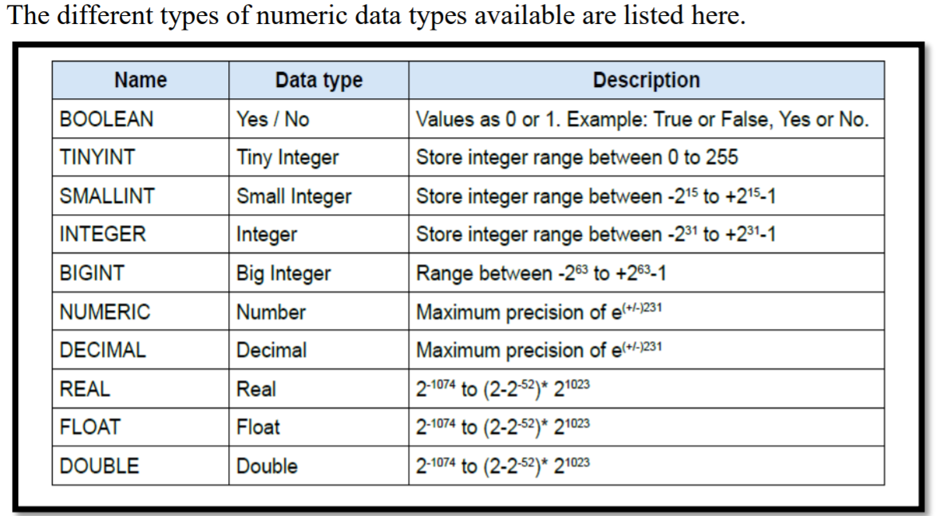

4. Define the structure of a table.

Ans. A table is a set of data elements (values) that is organized using a model of vertical columns(which are identified by their name) and horizontal rows. A table has a defined number of columns, but can have any number of rows. Each row is identified by the values appearing in a particular column identified as a unique key index or the key field.

5. Differentiate between Tuples and Attributes of a table.

Ans. Tuple represents one complete unit of information about an entity, one record(one row) in a table. Each row in a table represents a set of related data, and every row in the table has the same structure.

Attributes or Columns or Fields: An attribute is a set of data values of a particular type, one for each row of the table. For example, cFirstName, or cLastName are fields in a row.

6. List datatypes available in Alphanumeric Datatype?

Ans. 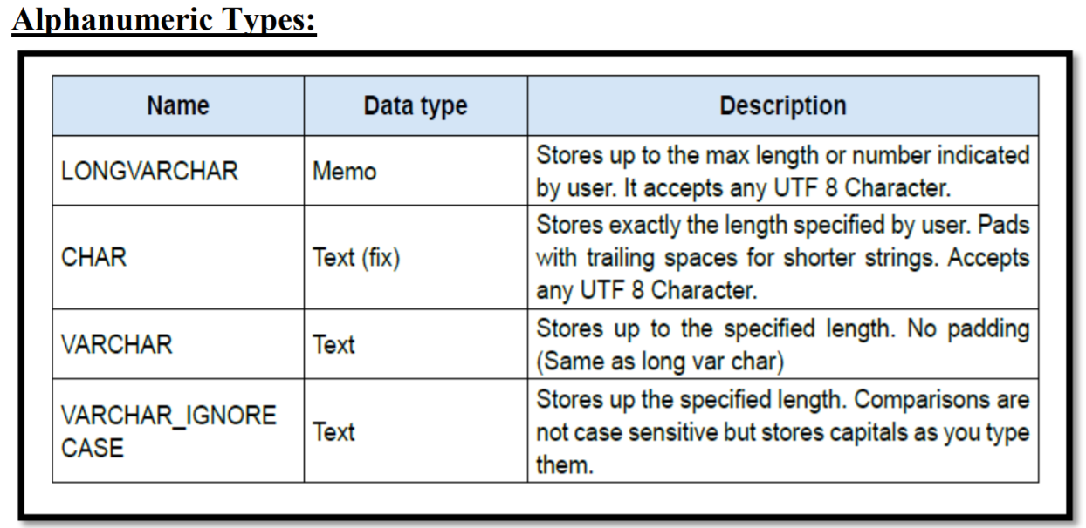

7. Name different Binary data types.

Ans. Different types of Binary data types are as follows:

